

Bansilal Ramnath Agarwal Charitable Trust’s

# Vishwakarma Institute of Information Technology

Business Intelligence and Data Analytics

(Assignments 4)

|  |  |  |  |
| --- | --- | --- | --- |
| Name | Roll No. | GR No. | Batch |
| Chetan Chinchulkar | 324017 | 21810350 | E9 (Comp D) |
| Nikit Gokhe | 324022 | 21810522 | E9 (Comp D) |
| Sahil Langha | 324032 | 21810533 | E9 (Comp D) |
| Kunal Parkhe | 324040 | 21810049 | E9 (Comp D) |

GROUP MEMBERS:

# Assignment No. 04

# Aim:

To create a dashboard using **Power BI** for your dataset for better understanding and clear view about your dataset. Also to learn about different visualization tools and techniques.

# Objective:

Create a dashboard using **Power BI** for the dataset chosen in previous assignments

# Theory:

# **What is a Dashboard?**

A dashboard is a tool used for information management and business intelligence. Much like the dashboard of a car, data dashboards organize, store, and display important information from multiple data sources into one, easy-to-access place. Using data visualization, dashboards uniquely communicate metrics visually to help users understand complex relationships in their data. In a data dashboard, it’s easier to draw parallels between different but related metrics, identify trends, and head off potential challenges hidden in an organization’s data.

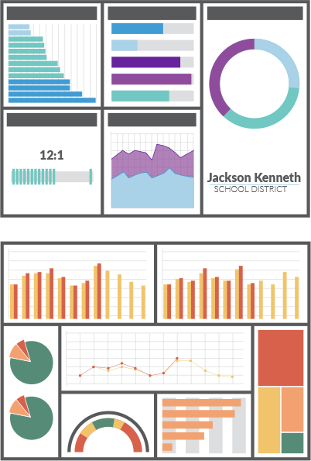

# Input:

**Name:** Credit Card Transaction (India)

**Dataset Reference:** Unknown source

# 

# Output:

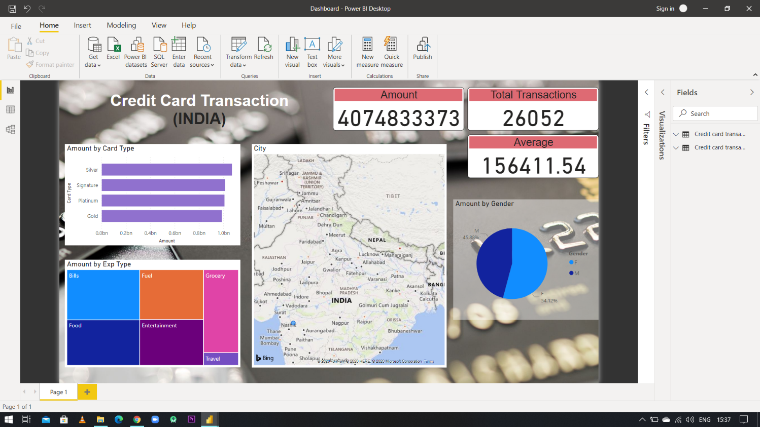

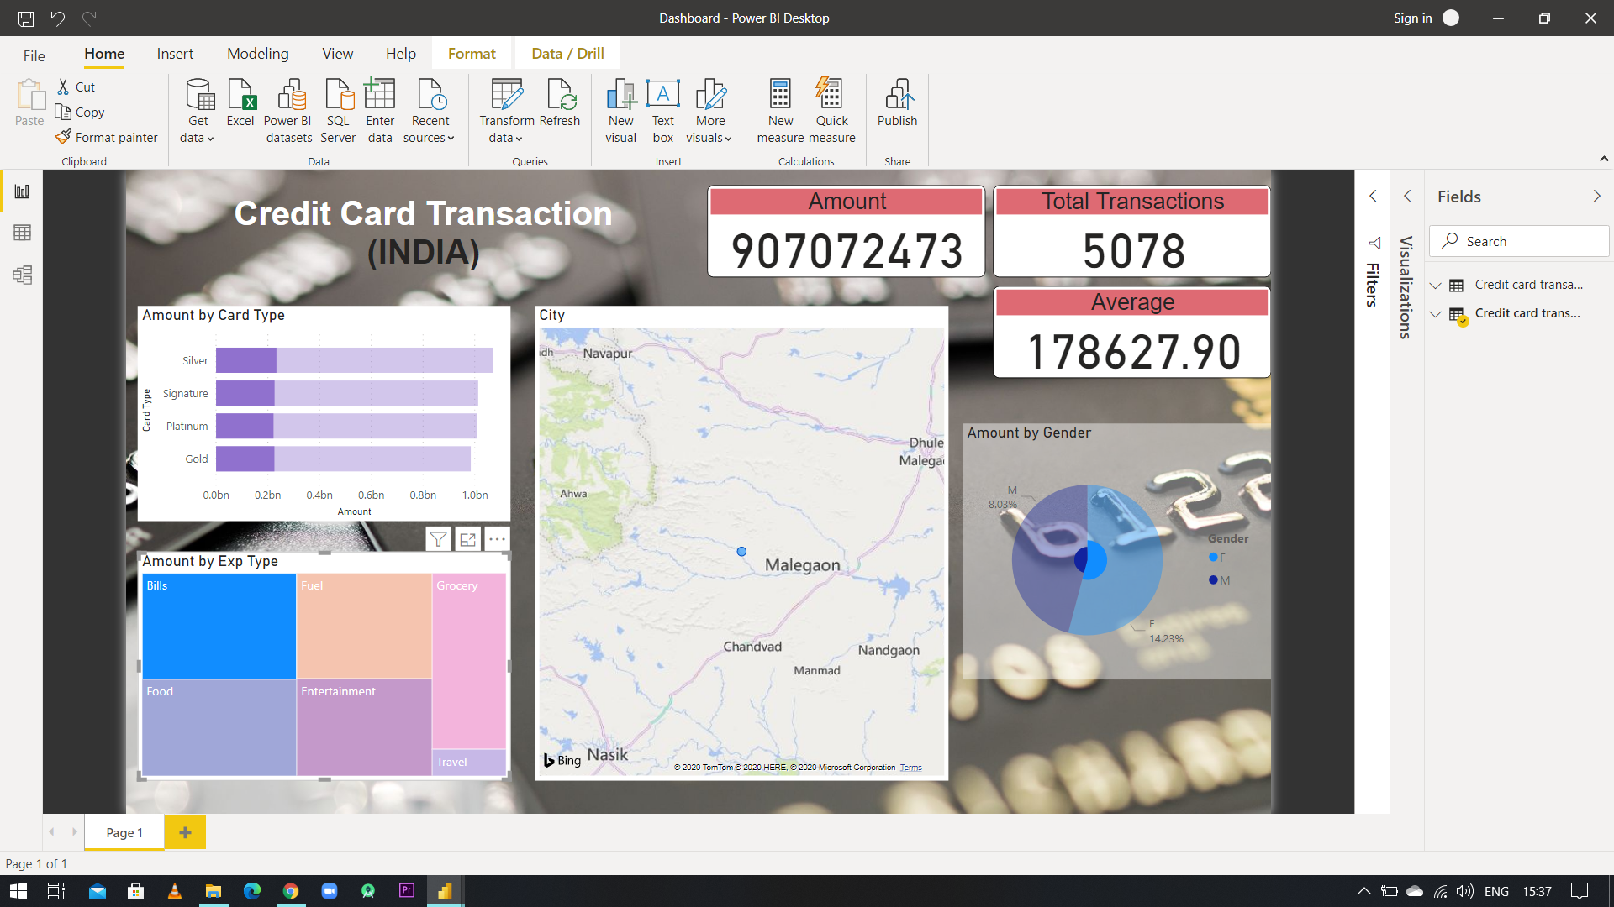

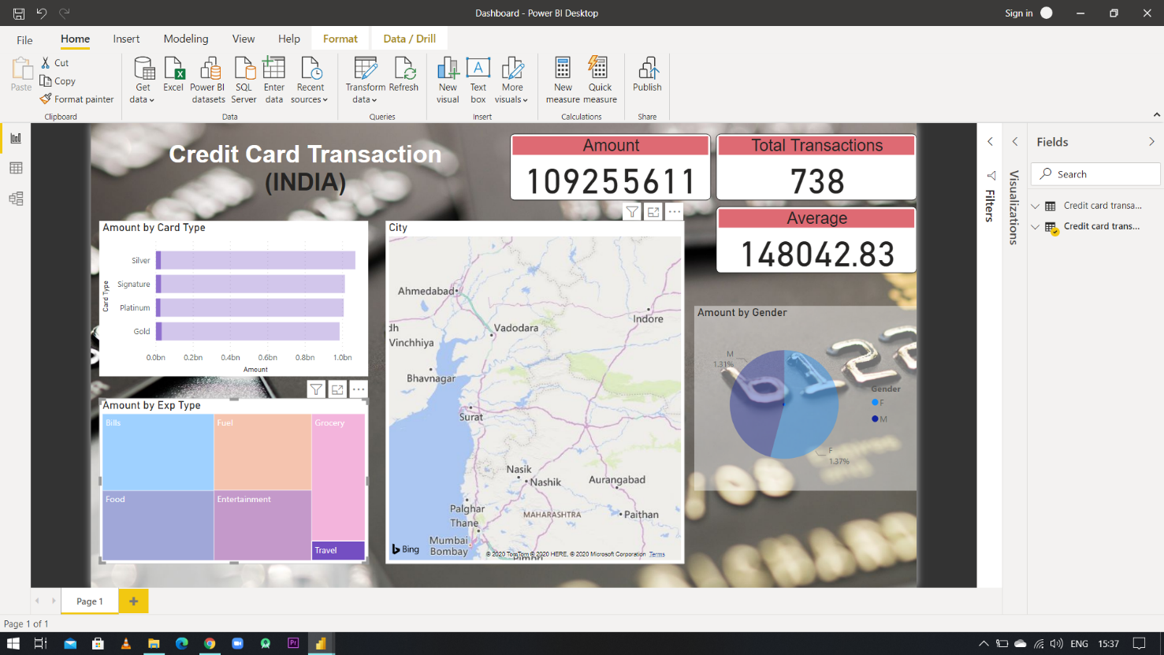

# Conclusion:

Created a dashboard which helps us to understand data in given dataset.

Also gives a clear view about specific details which we need.

Dashboard we’ve created, helps us to find out how many customers are there in a particular region and how much amount is spent on a particular category of transaction.